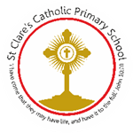
Child Protection Procedures Flow Chart
On discovery or suspicion of child abuse - ACT
If in doubt ACT

Inform your Designated Safeguarding Lead (DSL) for Child Protection

Designated Safeguarding Lead named here
Roxanne d’Arcy


If DSL cannot be located, then please contact one of the following:

Deputy DSL  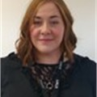  Laura Bowles | Deputy DSL    Claire Tidgwell | Deputy DSL  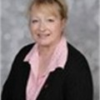  Jayne Dunn | Deputy DSL  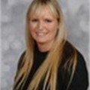  Noami Hannah

In the event the identified people are not available and there is a safeguarding concern, please refer to Children’s Initial Contact Point on 01274 433999.
If you are asked to monitor the situation, make sure you are clear what you are expected to monitor, for how long, and how and to whom you should feedback information. On discovery or suspicion of child abuse - ACT If in doubt - ACT Remember to always make and keep a written record of all events and actions taken, date and sign each entry to this record. Keep records confidential and secure and separate from the child’s curriculum file. Inform your Designated Safeguarding Lead (DSL) for Child Protection Designated Safeguarding Lead named here If DSL cannot be located, then please contact one of the following: Deputy DSL named here Deputy DSL named here Deputy DSL named here Always demonstrate professional curiosity by following up with the DSL whether action has been taken and where appropriate how it has been resolved. Staff should not assume a colleague, or another professional, will take action and share information that might be critical in keeping children safe. Always remember, safeguarding is everyone’s responsibility.
On receipt of the information the DSL should take the following steps: Where it is clear that a Child Protection Referral is needed contact Children’s Initial Contact Point without delay Tel: 01274 433999 Out of hours Emergency Duty Team Tel: 01274 431010 Where the DSL is not sure whether it is a child protection issue, they may seek advice from the Education Safeguarding Team
Tel: 01274 437043
SAFEGUARDING: SPEAK UP — WE WILL LISTEN
Everyone at our school has the right to feel safe, respected and supported.
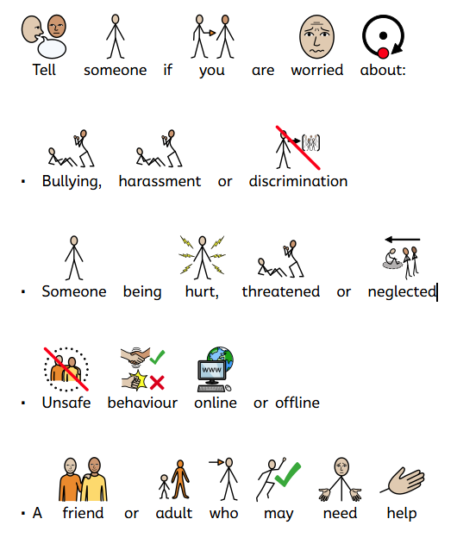
What to do:
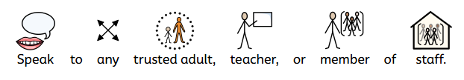
Our Safeguarding Team
DSL  Mrs d’Arcy | Deputy DSL  Mrs Bowles | Deputy DSL  Mrs Tidgwell | Deputy DSL  Mrs Dunn | Deputy DSL  Mrs Hannah


